Unit 9 Software Programming Variances

**Corey Crooks**

**Purdue University Global**

**IT401 Project Management II**

**Steven Long**

**November 22nd, 2023**

**Requirement 1: SV and CV Analysis**

The different variance algorithms in place for project management can give a decent read-out of the budget and schedule statistics. The cost variance is computed by determining the earned value of a project, and subtracting with the actual cost of the project (Project Management Institute, Inc., 2008). This can be translated to this Software Development Project where the formula becomes CV = 2,100 – 2,000. This will return the result of 100. This number being positive suggest that this project is actually underbudget at the moment, and weighs well with planned circumstances. Another algorithm to use would be the Schedule Variance. This can give a decent impression of the overall plan, and how it is preceding in actuality. This can be determined by taking the Earned Value, and subtracting the Planned Value. This translates to the project with SV = 2,100 – 2,400. Unfortunately, this returns the result of -300. Given that this is a negative number, the project is currently behind schedule.

Overall, I do not believe that the situation is as bad as the customer is suggesting. This project may be behind schedule, but it is actually underbudget as it stands now. I would answer to the customer with a breakdown of the project statistics as discussed above, and start a discussion about how the expectations of this project are unfolding in reality. We could then discuss the ramifications of continuing the project’s development based on the current project trends, and whether or not finishing this project would or would not jeopardize stakeholders.

Ultimately, I am confident that this project stands in no current peril regarding these statistics. My actions going forwards would be to recommend an implementation of an Agile development approach. It seems given the circumstances that certain risk factors and unknown variables are damaging the reputation of this project. With an agile approach, there would be more communication flowing from the development team about roadblocks and solutions (Joubert, 2021). This would in turn increase the faith of investors, management, and stakeholders in the development team by creating a more transparent work structure.

**Requirement 2: Cause-and-Effect Diagram**

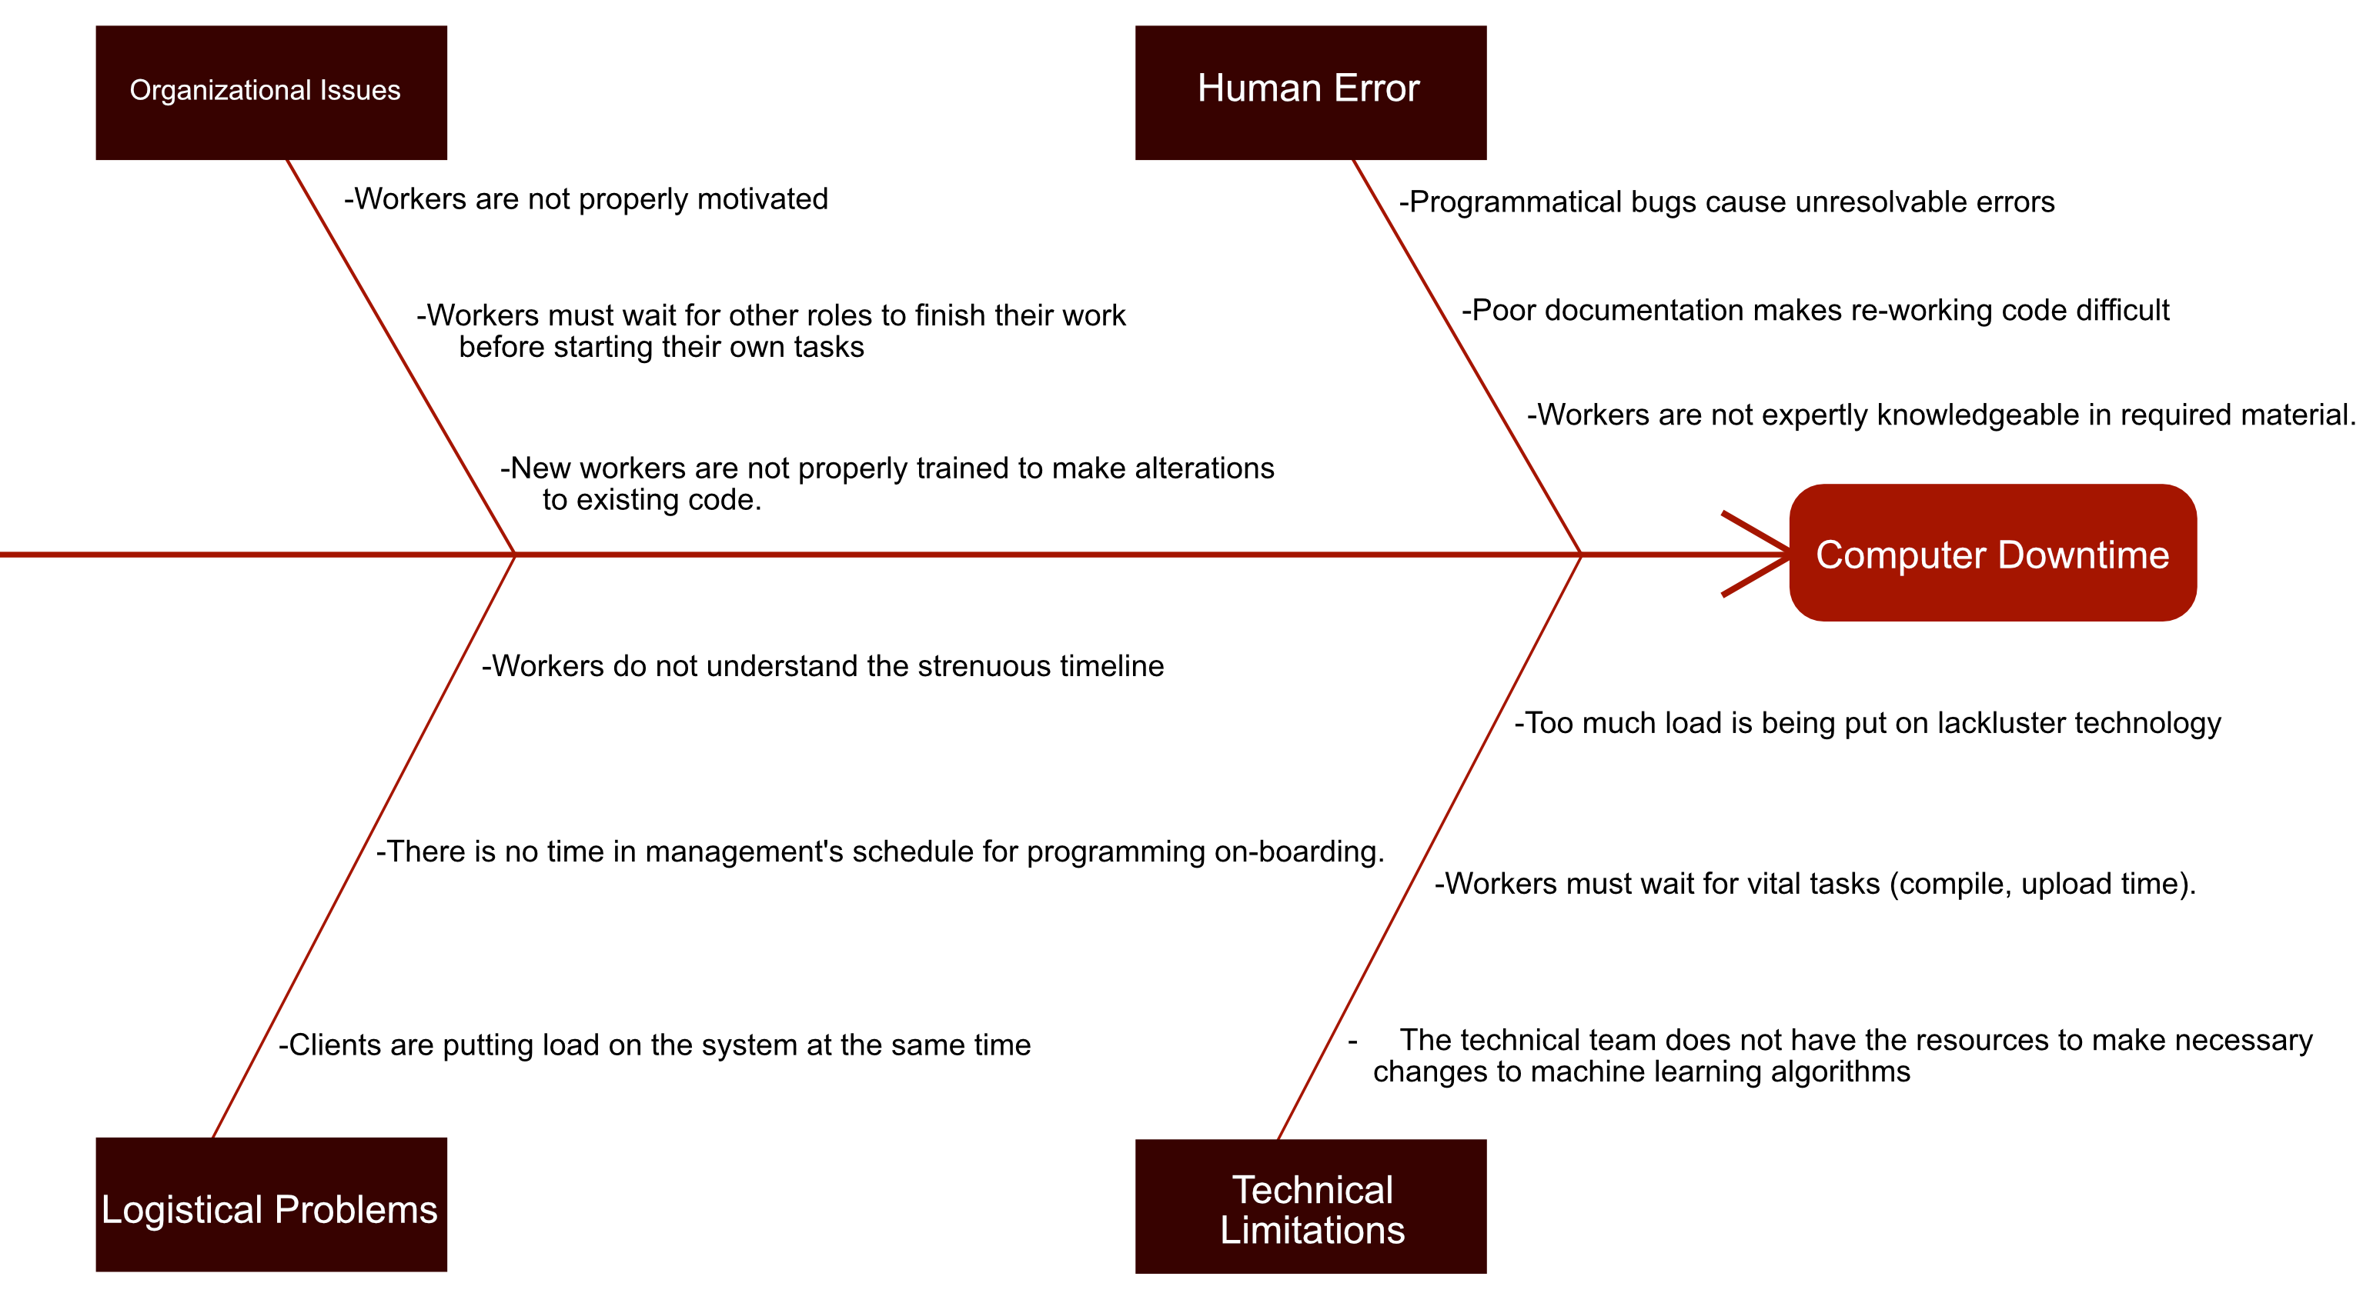

# **References**

Joubert, S. (2021, March 25). *Agile vs. Scrum: What's the Difference?* Retrieved from Northeastern University Graduate Programs: https://graduate.northeastern.edu/resources/agile-vs-scrum/

Project Management Institute, Inc. (2008). *Guide to the Project Management Body of Knowledge (PMBOK Guide), 4th ed.* Retrieved from Newton Square, PA: Project Management Institute, Inc.: https://open.lib.umn.edu/projectmanagement/chapter/9-2-managing-the-budget/